Summary for pre-read

WBR - Summary (for Pre-Read)

1) DLD Market
The DLD Sale market continues its growth at +15% YoY (MtD 8 Feb), with primary at +17% YoY; Secondary at +13% YoY.

2) Commercial
Sales Forecast: AED 60.7M vs 62.6M target (97% achievement). Forecast at 91% with upside to 97%; conservative spending on Diamond accounts.
Net Exclusive Listings: Rebaselining decision taken: non-compliant and duplicate listings will be removed. 7 action items with ETAs Feb 16 - Apr 9.

3) Demand
SEO SoV: 42.2% (+1.1pp) WoW on an improving trajectory
Paid Web Funnel: Sessions (534k, +3pp vs target), while leads are 57k (-13% vs target) and CR at 10.8% (-2.1pp vs target). Feb 7-8 marketing feed disruption caused ~54% decline in sessions and ~40% decline in leads. Feed reverted Feb 9; pacing normal since.
App Total Funnel: App funnel has met target as Sessions are at 673k (+1% vs target), Leads at 152k (11.3% vs target), CR at 22.6% (+2pp vs target)

4) Data Governance: Direct, SEO, and App CRM data cleanup in progress; CHEQ spam implementation ongoing.

5) New Projects (Primary)
Gross Revenue: Has met target (158k, +10% vs target)
Sessions and sold leads: Are under the target by >-10% (Sessions: 86k, Sold leads: 1.7k)

6) B2C App
App engagement & installs: Installs at 22.9k (+50% vs target and +45.5% YoY)
App ratings: Android ratings at 4.3 (-0.1 vs previous week) and needs to be watched out

7) B2C Tech
CWV Mobile INP Good Rate at 70.6% (below 75% CWV threshold, target 72%). Search template optimization and JS/main-thread reduction in progress. ETA: 72% in 4-6 weeks; 75% by end Q2.
Apdex Scores Android: Android Apdex drop due to auth API failures (RCA in progress)
Apdex Score iOS: 93.8% vs target of 95% due to a new SDK release

8) B2B Performance
App active agents: 10,440 (+0.7% vs target) is growing
WAU: 3,444 (+8.1% vs target, +1.1% WoW).
Incident Volume: P0: 0 (vs 1.3 target), P1: 12 (vs 17 target)

DLD Market Growth

Property Finder
Weekly Business Review

Market (Dubai)
- Overall market (AED 14.4B) continues to grow at 15% YoY (MtD 8 Feb), led by Primary Segment (+17% YoY) and secondary growing at +13% YoY
  - The trend remains similar even if we remove outliers (i.e. >100M deals)

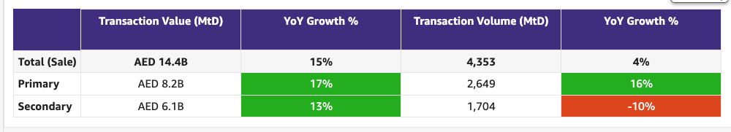

Commercial

Commercial
Category | DRI | Which metric is red and why | Actions planned | ETA for target achievement
Sales forecast % | Vladimir Malugin | Forecast at 91% with upside to 97%. It is driven by  - Conservative spending for Dubai Diamond accounts:  - Paragon Properties: +8% increase on current base (vs 26% growth target). Performing well as an Edge client, but unwilling to stretch further given perceived benefit realization.  - Mega Homes FZC: Intends to maintain current spend vs 116% target. Historically conservative decision-making, with recent stronger conversion on Bayut reducing urgency to grow investment.  - DXB NB at 78% | Continued focus on increasing sales through the following actions:  - Operational Excellence: Weekly Salesforce hygiene updates to ensure clearly identifiable, actionable records; strong focus on customer centricity (100% OK rate + structured client feedback) and proactive pipeline & sales risk tracking.  - Account Plans: Structured plans in place for key accounts to drive focused growth and retention  - Renewal Narratives: Strong partnership with Commercial Analytics to build clear, data-backed renewal stories for Diamond and Ruby accounts
Exclusive Listings | Prateek Goel | Rebaselining decision has been taken: Non-compliant listings and duplicate listings will be removed from baseline. Target setting will be conducted again once rebaselined data is ready | Updates from last weekly meeting:  1. New Business SPIFF for Exclusive Listings  Owner: Commercial Strategy  ETA: 20th Feb  2. Non-Compliant Listings  • Baseline recalibration  Owner: BA team  ETA: To be confirmed  • WA reminder to agents  Owners: Hugs, Sajjad  Action: Confirm current notification logic and how we can enable notifications to agents  ETA: Update by 19th Feb  3. Automatic Import of BY Exclusive Listings on Expert  Owner: Hugs  ETA: 16th March  Legal alignment meeting on 17th Feb  Dependency on DE team for daily scraping  4. CPL Discount on BY Exclusive Listings  Owners: Anirudh  ETA: 9th April  Next step on selection of clients x communities after rebaselining effort  5. Milestone-Driven Benefits (incl. SuperAgent Points – “First to PF”)  Design: Hugs and Sajjad to share initial thoughts on proposal by next week's meeting (19-Feb)  Dependency on DE team for daily scraping  6. Compass Data Narrative  Owner: BA team  ETA: 28th Feb  Meanwhile we will start with top 20 clients reach out for which GTM owner is Commercial Strategy/CSP, in collaboration with CX team  7. Community Performance Marketing  This will be handled in the revised “Top Communities” definition to be done by the BA team  ETA: TBD

Weekly Metrics
 |  | Weekly |  |  |  | MTD
Category | Metric | Week  (Actual) | Week (Target) | WoW | vs 2 weeks prior | MtD  (Forecast) | Month (Target) | vs MtD  prev month (MoM) | vs MtD  prev year (YoY) | vs competition | DRI | Dash
Sales  (MtD) - UAE | Sales Forecast %  (Month-end) | Monthly -> |  |  |  | 60.4 Mn  (97%) | 62.6 Mn | Not Applicable | Not Applicable | Not Applicable | Vladimir Malugin | Link

CLEL to not be discussed in Q1, till baseline is defined and Product actions are in place

Category | Metric | Week  (Actual) | Week (Target) | WoW | vs 2 weeks prior | MtD  (Actual) | Month  (Target) | vs MtD  prev month (MoM) | vs MtD  prev year (YoY) | vs competition | DRI | Dash
Net exclusive listings | Rent | 3.6K | NA | +0.7K  2.9K | +0.3K  3.3K | NA | NA | NA | NA | Not Applicable | Prateek Goel
 | Sale | 12.4K | NA | -0.2K  12.6K | -0.3K  12.7K | NA | NA | NA | NA | Not Applicable | Prateek Goel
Supply | Net Exclusive Listings | 16K | NA | +0.5K  15.5K | 0K  16K | NA |  | NA | NA | Not Applicable | Prateek Goel
 | Total Listings | 370.1K | NA | +1.4K  368.7K | +1.7K  368.4K | NA | NA | NA | NA | -139.5  509.6K
 | Dubai | 215.7K | NA | +1.4K  214.3K | +4.4K  211.3K | NA | NA | NA | NA | -5.1K  220.8
 | Abu Dhabi | 16.9K | NA | +0.4K  16.5K | +0.8K  16.1K | NA | NA | NA | NA | +1.8K  15.1K
 | Northern Emirates (incl Al Ain) | 137.5K | NA | -0.4K  137.9K | -3.5K  141K | NA | NA | NA | NA | -131.7K  269.2K

Primary (NP, Media, Dev)

Primary (New Projects, Media Sales)
Category | DRI | Which metric is red and why | Actions planned | ETA for target achievement
New Projects | Enguerran Milhiet | - Sessions: impact of SEO initiatives lower than expected.  - Sold leads: impact of lower sessions.  - Despite lower sessions and sold leads, still above revenue target (higher average selling price). | - Accelerate SEO initiatives (community reviews).  - Further push usage of open leads v2 to increase conversion. | - February expected green in revenue and sold lead.
Media & Developers | Sami Awada | - February still at 100%. | - N/A | - N/A

î

Demand (Paid/Unpaid)

Demand
Category | DRI | Which metric is red and why | Actions planned | ETA for target achievement
Paid | Ahmed Osman | - Web Paid Listing Leads: Between Feb 7–8, we experienced a temporary issue with our marketing feeds that disrupted campaign delivery and reduced paid sessions and leads. | Incident Summary:  The Acquisition team deployed a structural update to split product images within the XML feeds. The objective was to enable marketing platforms to better interpret and prioritize visuals in dynamic ads to improve creative performance. However, this change unintentionally affected feed validation, causing associated catalogs to fail. As a result, campaigns dependent on these feeds stopped delivering.  Observed Impact:  Campaigns using the affected product feeds under-delivered on Feb 7 and saw low to no delivery on Feb 8. This led to an approximate 54% and 40% decline in sessions and leads, respectively, from impacted channels compared to preceding days.  Resolution:  The catalog changes were reverted on Monday, Feb 9, which restored feed validation. Campaign delivery returned to normal shortly after the fix.  Preventive Measures:  - Catalog-related updates will no longer be deployed on Fridays to avoid reduced monitoring coverage over weekends.  - All feed modifications will undergo validation and testing before production release | - We’re pacing as per our usual run rate since Monday 9th of Feb.
Unpaid - SEO | Mahmoud Nessim
Unpaid - Overall | Soumar Aoun | - App is green  - Web direct is still being fixed under data governance. Data to be ready by next week. | B2C Shipping Momentum (Past 2 Weeks → Next 2 Weeks)  - Strong shipping velocity across Discovery + CRM, with multiple initiatives now fully rolled out and showing early conversion and engagement gains (Travel Time Search, Web Nav, CRM Expansion).  - CRM is starting to unlock real leverage, delivering 2.5x opens and +100% uplift in CRM-driven sessions during the test period.  - Key experiments are progressing well, including 2D Floor Plans, PLP Revamp, Scarcity Tags, and Personalized Recommendations.  - Next wave through end of February is focused on the highest-leverage bets:  Login acceleration, PLP conversion uplift, deeper engagement loops, and SERP revamp landing 27/2.  - AI Search remains stable post-toggle on default removal, with error rate <3% and a dedicated squad mobilizing in early March to accelerate roadmap delivery.  📌 Full initiative-by-initiative breakdown (design links + owners + readouts) available in the detailed Shipping Update doc. | N/A

Competition:
1. SoV - SEO
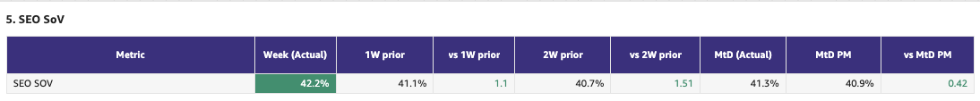
2. Demand Funnel
(Direct and SEO Data are currently being fixed under Data Governance Workstream)

Web - Paid
App-Total

Exposure LPL
(EXCLUDES DIRECT)

Leads and Listings distribution
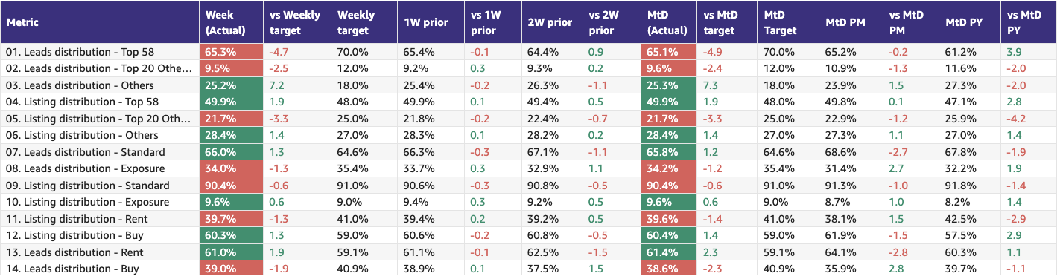

Rent vs Buy Split
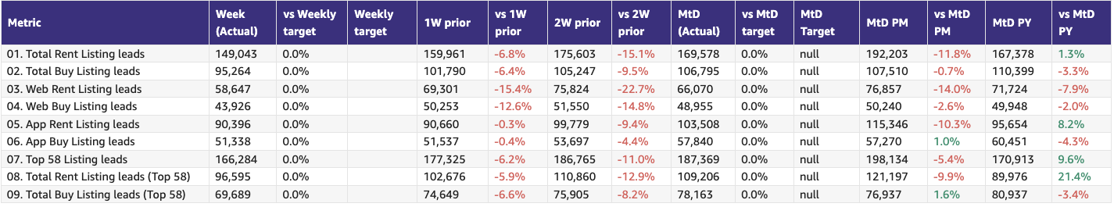

Monthly Metrics

B2C NPS
Category | Metric | MtD  (Actual) | Month (Target) | vs MtD  prev month (MoM) | vs MtD  prev year (YoY) | vs competition | DRI | Dash
B2C NPS | B2C NPS |  | Not Available |  |  | Not Available | Alson Dsouza

PR Metric
Category | Metric | MtD  (Actual) | Month (Target) | vs MtD  prev month (MoM) | vs MtD  prev year (YoY) | vs competition | DRI | Dash
PR | PR Sov | 99.1% | 50-55% |  |  | 0.1% Bayut  0.8% Dubizzle | Natalie Faulkner | PR team

Leads click to delivered:
Category | Metric | MtD  (Actual) | Month (Target) | vs MtD  prev month (MoM) | vs MtD  prev year (YoY) | Δ vs Competition | DRI | Dash
Leads Funnel | Total Leads Delivered (WA) |  |  |  |  | Not Available | Olivia Watters | Link
 | % Clicks to Delivered (WA) |  |  |  |  | Not Available | Olivia Watters | Link
 | Error Leads (WA) |  |  |  |  | Not Available | Olivia Watters | Link

- Competition
  - Share of Session (Overall, Web Channels, App Channels)
  - SoV - Paid click share

- Demand Funnel
  - Sessions (by channels)
  - Leads (by channels)
  - CR (by channels)
  - Click to Delivered

- Exposure LPL
  - Overall / Rent / Sale
  - Top Communities
  - Web/App
  - Exposure Leads as % of Total Leads (Overall / rent / sale)
  - Exposure Listings (Overall / rent / sale)

- Engagement Metric (Time on site)
- B2C NPS
- PR SoV - we are way ahead of the competition in terms of SoV at 99.1% - thanks to a number of press stories, including our latest Market Watch report and trends.
- Leads split by Rent vs Buy

Data Governance

DATA GOVERNANCE
Data Issue | Latest update | Resolution update (ETA) | DRI
Spam Issues | - Remove spam activity from all reporting tables across both GA4 and Snowplow leveraging third party tool (Cheq)  - Assess the need and feasibility of leveraging cheq spam classification into delivered leads spam detection model  - Define tech solution to block “bad” spam activity so it can be prioritized during Q2 roadmap planning | - 24th February  - 20th February  - 6th March | Ram Moorthy
SEO (Sessions vs clicks) | - Agreed on starting reporting SEO traffic as-is once spam activity is removed | - 24th February | Ram Moorthy  Volkan Oktem
CRM Attribution Reporting | - Route-cause assessment ongoing | - 27th February | Ram Moorthy
Kochava Integration Update | - Upgrade Kochava integration, i.e. data transformation to happen in PF infra1. | - 4th March | Khaled Thabit

B2C App Engagement

B2C App
Category | DRI | Which metric is red and why | Actions planned | ETA for target achievement
App engagement & installs | Ahmed Osman | - Green | - Planned activities for the remainder of Q1, focused on more diversified messaging (HV, My Activities, New Simplified UI, Travel Time). | - Consider reviewing MAU targets to reflect a potential YoY increase.
App ratings | Soumar Aoun | - Green | - N/A | - N/A

Weekly Metrics -

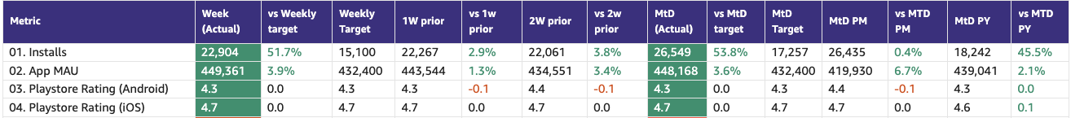

- App Installs
- App MAU
- DAU/MAU
- Sessions / DAU
- Login Ratio
- Avg Session Duration
- Playstore rating (Android)
- Playstore rating (iOS)\

B2C Tech Metrics

B2C App
Category | DRI | Which metric is red and why | Actions planned | ETA for target achievement
App stability & performance | Taran Kambow | Android: -  Apdex drop is due to authentication API network failures; the team is investigating.  iOS :-  Luciq’s new SDK release | - Android:  - RCA in Progress  - iOS:  - Hotfix to roll back Luciq SDK on Feb 13th (Will continue to see RED next week as well) | Android:  - Next Week  iOS:  - Feb 13th
Web Stability & Performance | Amory Kelie | - Mobile INP Good Rate at 70.6%, below 75% CWV threshold.  - Interaction delays concentrated in high-traffic search templates due to JS execution pressure. Primary SEO entry pages remain stable. | - Search template optimisation and JS/main-thread reduction work in progress. | - Stabilise to 72% in 4–6 weeks; reach 75% by end of Q2.

 |  | Weekly |  |  |  | MTD
Category | Metric | Week  (Actual) | Week (Target) | WoW | vs 2 weeks prior | MtD  (Forecast) | Month (Target) | vs MtD  prev month (MoM) | vs MtD  prev year (YoY) | vs competition | DRI | Dash
Tech stability & Performance | Mobile INP Good rate (%) | 70.6% | 72% | -1pp | -1.2pp | NA | NA | NA | NA | NA | Amory Kelie

- Appdex: Android
- Appdex score: iOS
- CWV

B2B Product

B2B
Category | DRI | Which metric is red and why | Actions planned | ETA for target achievement
CSAT (P0s) | Luis Cappa | BAU - Nothing relevant to call out this week.  We received only 12 P1s across 5 teams (2.15 tickets / team). We are Green to complete our Monthly Target Goal (max 6 P0s, max 73 P1s). | N/A | N/A
Agent Experience | Sajjad Ahmad | In Green

Weekly Metrics

 |  | Weekly |  |  |  | MTD
Category | Metric | Week  (Actual) | Week (Target) | WoW | vs 2 weeks prior | MtD  (Actual) | Month (Target) | vs MtD  prev month (MoM) | vs MtD  prev year (YoY) | vs competition | DRI | Dash
CSAT | Incident Volume | P0: 0  P1: 12 | P0: 1.3  P1: 17 | P0: 0% (0)  P1: -8% (13) | P0: -100% (1)  P1: -40% (20) | P0: 0  P1: 22 | P0: 6  P1: 73 | P0: +0 (0)  P1: +40% (10) | P0: -1 (1)  P1: +17% (12) | Not Available | Luis Cappa | Link  (JIRA)

Agent Engagement & Experience | App active agents | 10440 | +0.7%  (vs 10361) | +2.5%  (vs 10190) | +5.1%  (vs 9935) |  |  |  | Not Available | Not Available | Sajjad Ahmad | TBA
 | Active users per week (WAU) | 3444 | +8.1%  (vs 3186) | +1.1%  (vs 3408) | -0.5%  (vs 3460) |  |  |  | Not Available | Not Available | Sajjad Ahmad | TBA
 | Agent NPS | NA | NA | NA | NA | Monthly Metric |  |  |  |  | Sajjad Ahmad | TBA

Listing Quality

Monetization
Category | DRI | Which metric is red and why | Actions planned | ETA for target achievement
Compliance | Saif Al-Amid | - In green | - Perform a clean of fake listings  - Add compliance and anti fake listings rules | - List of actions here with ETA’s.

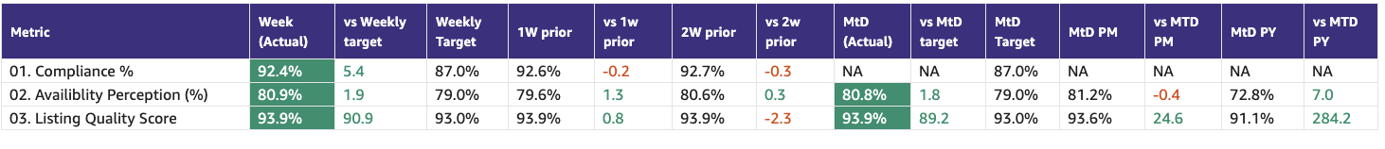

Special Projects
Monthly Lookbacks

Converting at risk clients to Promoters Ivan Gregorc Status
- Expected achievement at the end of the quarter. Based on current progress, what’s the estimated achievement rate for the end of Q1 2025?
By end of Q1, we expect to convert 50%+ of Neutral/Detractor clients into Promoters and protect renewal risk across the Marketing-owned portfolio (21 clients).
Assuming delivery on Product-dependent items.
- Achievement (till date) : Indicate completed and pending tasks.
- Client sentiment baseline established and tracked weekly
- Identified top 6 elements to turn Neutral clients into promoters
- Active engagement in place for all Target clients
Pending:
- Product fixes impacting SuperAgent points and lead quality
- Clearer value narrative on Premium Listings
- Impediments : If applicable, what is delaying the progress?
- The majority of blockers are Product-dependent
- Some perception issues (Awards, Premium value) require time and repetition to shift
- Initiatives to address impediments: What actions will we take to address the above issues or improve results?
- 4 out of the 6 (Spam Leads, Split Deals, Agent Engagements, PF Awards, Draft Listings) major issues brought up are being addressed by end of Q1
- 1 out of the 6 (Cost of Premium Listings) will be partially addressed by end of march through bundles rollout
- 1 remaining issue, the top 1, (SuperAgent Point System disadvantage in lower price-point communities) is being addressed by End of Feb.
Link to deep dive document

Special Projects - Q1 OKRs
Keyper Soumar Aoun Status

Bundles Paresh Goyal Status
- 21 client meetings completed as part of the validation phase
- Overall strong positive response on bundles, especially relating to SP/SF, credit discounts and ranking boost
- Key ask raised around limiting bundles to only a select set of clients and not everyone, in order to drive competitive advantage

North Stars

 |  | Month
Category | Metric | MtD  (Actual) | Month  (Target) | vs MtD  prev month (MoM) | vs MtD  prev year (YoY) | DRI
Output metric | Share of Wallet | 52.5%  (Dec 2025) | NA | -0.2pp | NA | Vladimir Malugin
North Star Metric | Share of Sessions | 57.8%  (Jan 2025) | 52.6% | +6.6pp  51.3% | +2.6pp  55.3% | Soumar AounAhmed OsmanMahmoud Nessim
North Star Metric | Net Exclusive Listings | 16k | 23k | -3.2K  19.2K | NA | Prateek Goel

Exposure LPL (EXCLUDES DIRECT - Both in targets and actuals)
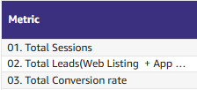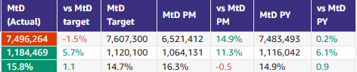
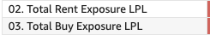

📋 Prev Saved Reports

Week | Date | Link
Week 5 | Jan 1 to Jan 31 | WBR - Jan Monthly Lookback (Saved Report) Metric Report
Week 4 | Jan 19 to Jan 25 | WBR - Week 4 (Saved) Metric Report
Week 3 | Jan 12 to Jan 18 | WBR - Week 3 (SAVED) Metric Report
Week 2 | Jan 5 to Jan 11 | WBR - Week 2 (SAVED) Metric Report
Year End.
W52 | Dec 1 to Dec 30 | WBR Metric Report - Dec Monthly Lookback (Saved Report)
W49 | Dec 1 to Dec 7 | WBR Metric Report - Week 49 (Saved Report)
W48 | Nov 1 to Nov 30 | WBR Metric Report - Week 48 - Nov Monthly Lookback (Saved Report)
W47 | Nov 17 to Nov 23 | WBR Metric Report - Week 47 (Saved Report)
W46 | Nov 10 to Nov 16 | WBR Metric Report - Week 46 (Saved Report)
W45 | Nov 3 to Nov 9 | WBR Metric Report - Week 45 (Saved Report)
W44 | NA | NA
W43 | Oct 1 to Oct 31 | WBR Metric Report - Week 43 - Oct Monthly Lookback (Saved Report))
W42 | Oct 15 to Oct 21 | WBR Metric Report - Week 42 (Saved Report)
W41 | Oct 8 to Oct 14 | WBR Metric Report - Week 41 (Saved Report)
W40 | Oct 1 to Oct 7 | WBR Metric Report - Week 40 (Saved Report)
W39 | Sep 1 to Sep 30 | WBR Metric Report - Week 39 (Saved Report)
W38 | Sep 17 to Sep 23 | WBR 2.0 Report - Week 38 (Saved Report)
W37 | Sep 10 to Sep 16 | WBR 2.0 Report - Week 37 (Saved Report)
W36 | Sep 3 to Sep 9 | WBR 2.0 Report - Week 36
W35 | Aug 1 to Aug 31 | Copy of WBR 2.0 Report - Week 35.docx
W34 | Aug 20 to Aug 26 | Copy of WBR 2.0 Report - Week 34.docx
W33 | Aug 13 to Aug 19 | WBR 2.0 Report - Week 33.docx
W32 | Aug 6 to Aug 12 | Copy of WBR 2.0 Report - Week 32.docx
W31 | Jul 30 to Aug 5 | WBR 2.0 Report - Week 31.docx

